* **Being a Receptive Communication Partner**
* Communication Challenges: Navigating Choppy Waters
* Diplomacy and Tact in Challenging Situations
* Lives the Values

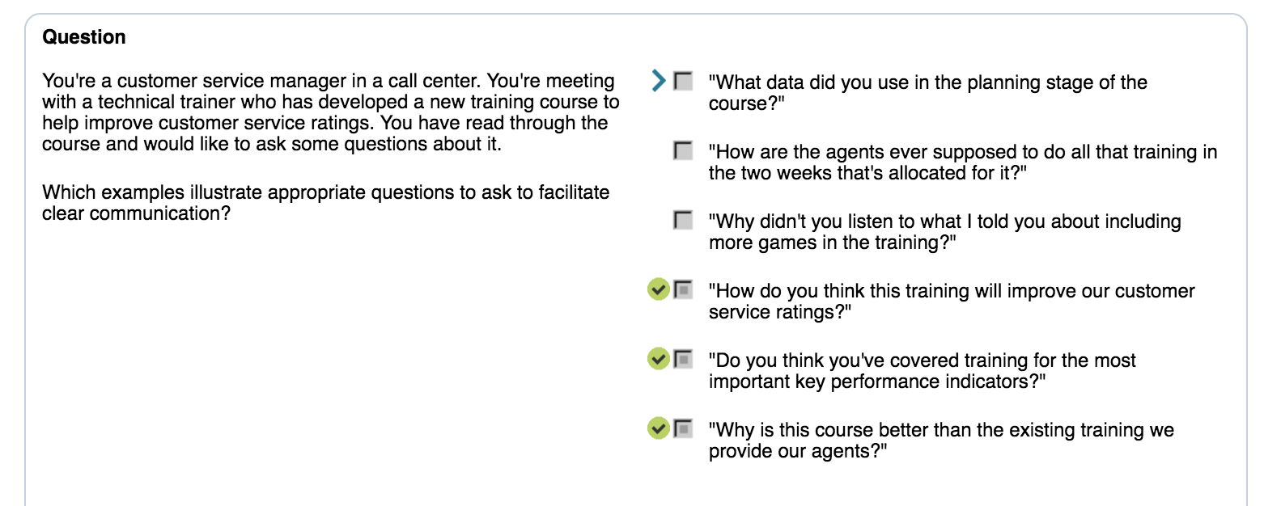

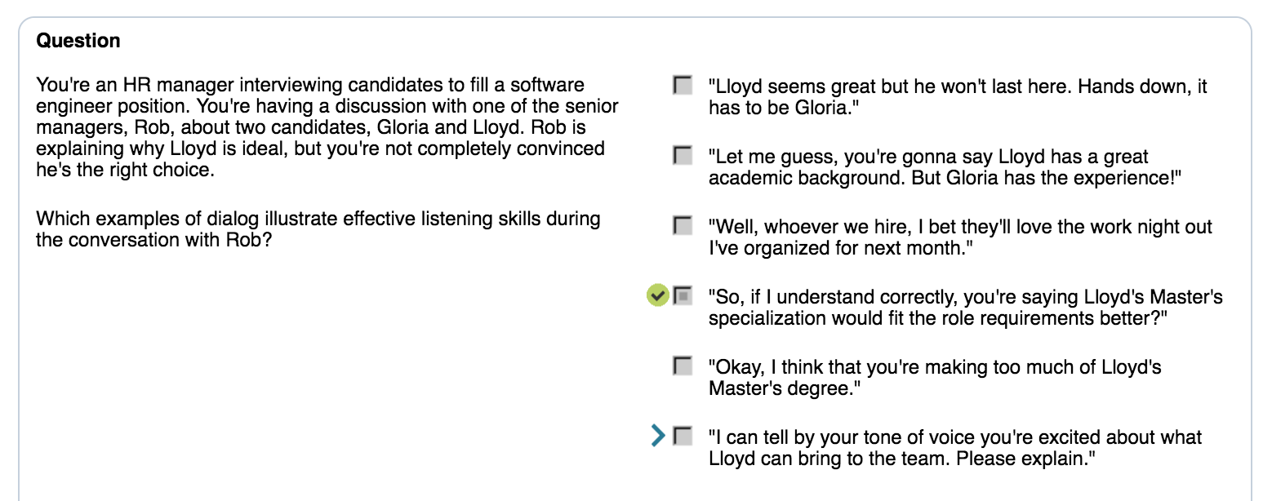

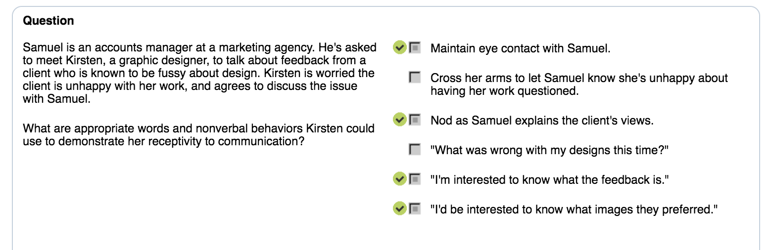

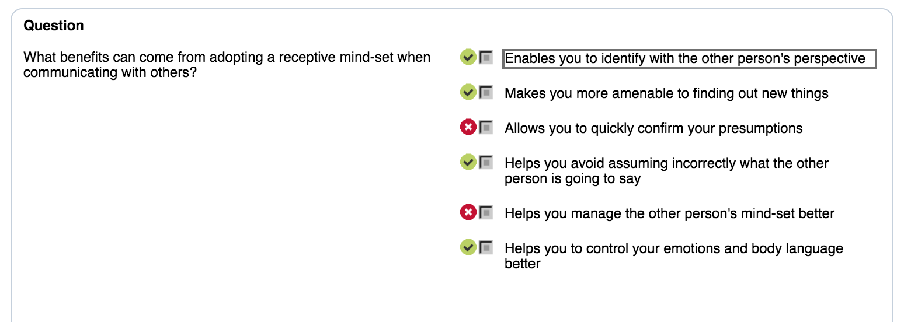

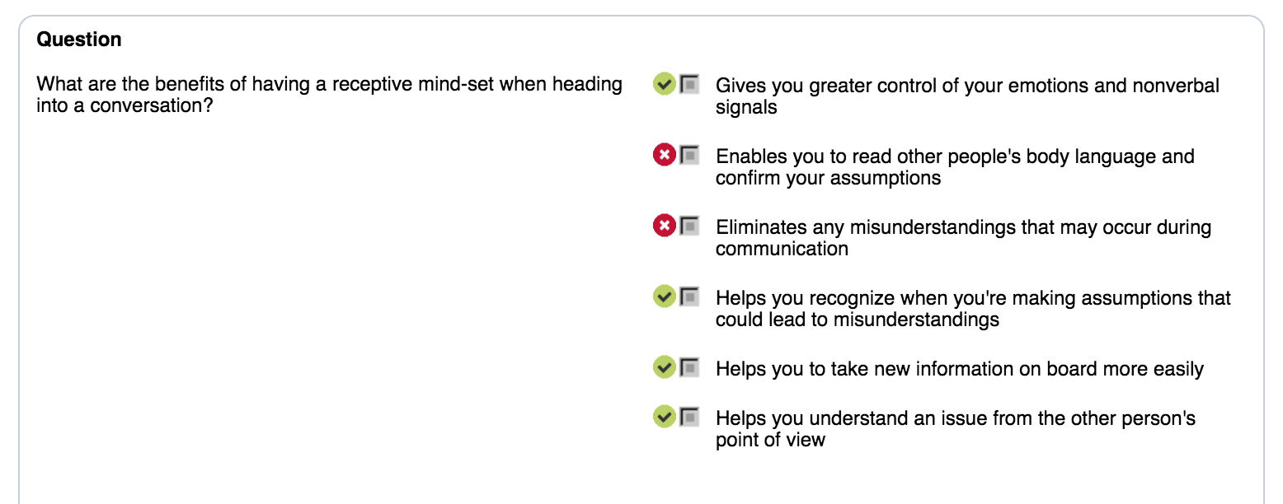

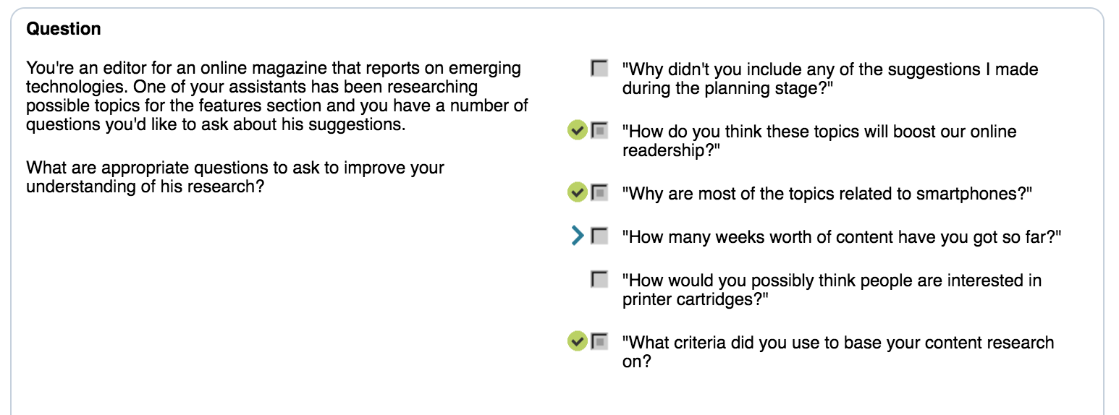

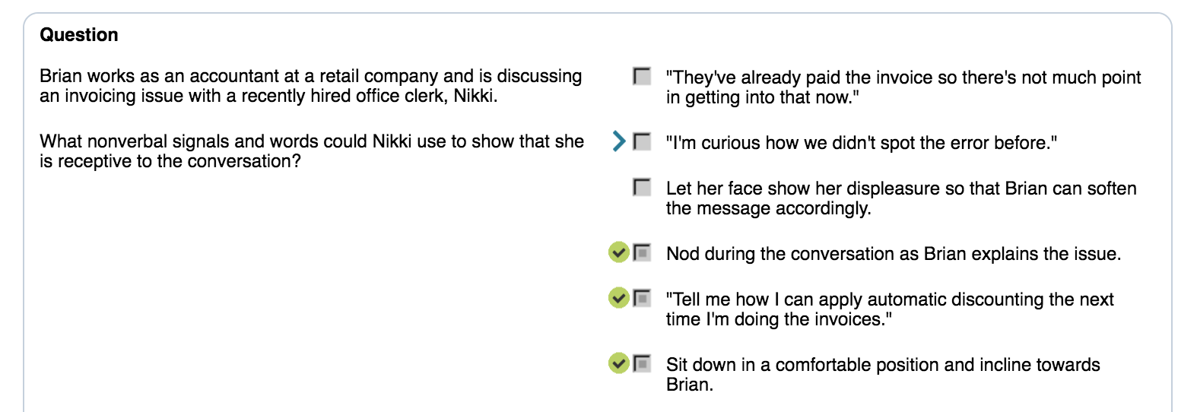

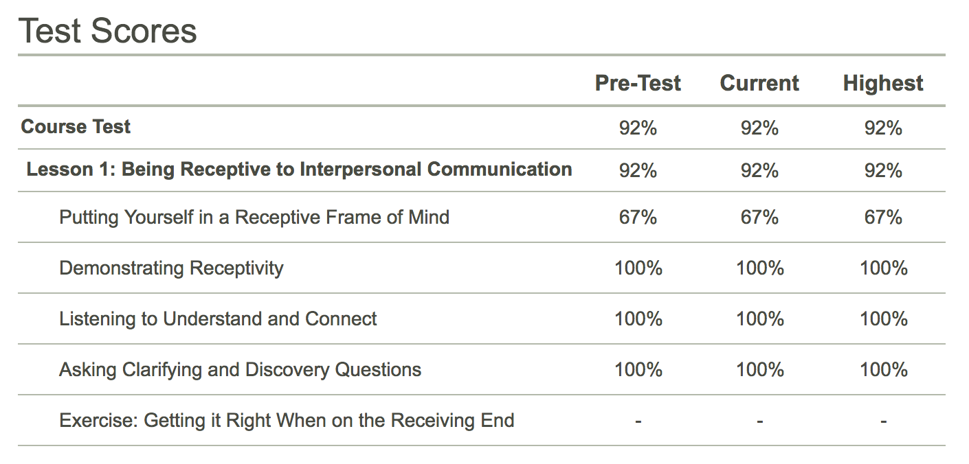

Being a Receptive Communication Partner

**Course Overview**

Read the [Course Overview](https://library.skillport.com/courseware/Content/cca/comm_35_a03_bs_enus/output/html/course_transcript.html#co27).

**Being Receptive to Interpersonal Communication**

[1. Putting Yourself in a Receptive Frame of Mind](https://library.skillport.com/courseware/Content/cca/comm_35_a03_bs_enus/output/html/course_transcript.html#t6)

[2. Demonstrating Receptivity](https://library.skillport.com/courseware/Content/cca/comm_35_a03_bs_enus/output/html/course_transcript.html#t10)

[3. Listening to Understand and Connect](https://library.skillport.com/courseware/Content/cca/comm_35_a03_bs_enus/output/html/course_transcript.html#t14)

[4. Asking Clarifying and Discovery Questions](https://library.skillport.com/courseware/Content/cca/comm_35_a03_bs_enus/output/html/course_transcript.html#t18)

[5. Exercise: Getting it Right When on the Receiving End](https://library.skillport.com/courseware/Content/cca/comm_35_a03_bs_enus/output/html/course_transcript.html#t22)

Course Overview

Nice…

*[Scene opens: The host catches a football.]*

Hey…just because I'm presenting this course doesn't mean you're not involved…

I mean what's the point if you're not engaged and listening? Sure, the lion's share of the responsibility is mine. I need to get my message across. But, in many ways, your response is as important as my message. When you're on the receiving end of a communication, regardless of the situation, or whether it's been planned or delivered effectively, you have a responsibility to be receptive. To understand what's intended. This involves two essential skills that most people find challenging – listening and questioning.

In this course, we'll work on sharpening those skills and getting you in the right receptive mind-set...

[Back to top](https://library.skillport.com/courseware/Content/cca/comm_35_a03_bs_enus/output/html/course_transcript.html#top)

Putting Yourself in a Receptive Frame of Mind

Learning Objective

*After completing this topic, you should be able to*

* *recognize the benefits that adopting a receptive mind-set has on your interpersonal communications*

**1. Get in a receptive frame of mind**

There you are….I need to talk to you….Operations has an issue with...

*[Scene opens: Joe walks up to Cary.]*

Look, Operations hasn't said a thing to me. Sales and IT are on board, and as far as I'm concerned, we're all on the same page.

*[Cary is defensive and crosses her arms.]*

OK. But they're telling me there could be systems compatibility problems down the line…

Here we go again. These "I need to talk to you" side meetings. He should have told me about Operations' issues before we kicked off the project. That's what he should be saying. It's his fault, not mine. Does he have any idea how much pressure I'm under? How much I have to do?

*[Cary tunes out and thinks to herself while Joe explains the problems.]*

So, I'll need you to fill Jessica in on this and put together a new agenda for Friday. OK?....Cary?

*[Cary is distracted by her own thoughts.]*

What? I mean…OK. I'll take care of it.

Hey, the deadline is tight but we'll get there. I know you won't let me down.

Oh no….I messed up! A new agenda? And now he thinks I'm the hero? Great.

*[Cary thinks to herself.]*

Wow, that was uncomfortable. Cary was defensive…judgmental…closed-minded. By tuning out of the discussion, she completely missed the message that Joe just wanted her help.

*[Cary walks off and the host returns.]*

Sometimes it takes "work" to have a receptive mind-set. You must quiet negative self-talk that tends to creep in, especially if you have assumptions about a person, or if someone doesn't set up the communication well – like saying "I need to talk to you." We can all be quick to judge someone or jump to a conclusion – sometimes it's "easier" than staying open.

But there are real benefits to adopting a receptive mind-set. For one thing, it prevents you from making incorrect assumptions that influence the communication. It makes you more open to learning new things. Being receptive also helps you keep your emotions and nonverbal signals calm and under control. And you'll find you're better able to understand and empathize with the other person's perspective.

A receptive mind-set can move you from self-understanding to understanding others. It's when you adopt a defensive, closed, judgmental mind-set that you're apt to have an unsatisfactory communication. Which brings us back to Cary. She learned the lesson the hard way.

So, next time you're in a situation that requires a receptive mind-set, check in with yourself. Are you listening? If so – great! If not, focus and be interested. Are you making assumptions? If so, set them aside. Are you open to learning new things? If not, put your preconceived notions on hold for right now. Are you aware of your physical and emotional state? Try to stay calm and receptive. And most of all, are you being sensitive to others? Remember they also have a mind-set to manage.

*[The video shows Cary talking on a cell phone.]*

If you stop and think about the other person, you can empathize with the challenges of interpersonal communication. So why not be receptive and make it easier on everyone?

[Back to top](https://library.skillport.com/courseware/Content/cca/comm_35_a03_bs_enus/output/html/course_transcript.html#top)

Demonstrating Receptivity

Learning Objective

*After completing this topic, you should be able to*

* *recognize behaviors that indicate receptivity to a communication*

**1. Use verbal and nonverbal cues**

And did you fill in the other part, the part Jessica was asking about…

*[Scene opens: Joe is sitting behind a desk and Cary sits on the other side.]*

More or less. I spoke with Jessica. She seemed to think you're not too happy I went to her with my concerns about integrating the systems.

Really? What did she say?

*[Cary is curious.]*

When you're in a conversation with someone, you show how receptive you are to their message in two ways: verbally, through what you say, and nonverbally, in your posture, body language, and gestures.

*[The scene switches to the host.]*

What's the point of getting into that?

*[The scene switches back to Joe and Cary. Joe is resistant and crosses his arms.]*

I'm just curious…interested. When I was talking to her yesterday…Maybe she misunderstood what I was getting at.

*[Cary is curious. Joe shakes his head and looks aloof.]*

Look. Why bother going through that now. The main thing is I've pretty much finalized the report.

*[Joe is defensive.]*

OK, so tell me about the report then. Can we combine analytics with optimization?

That's not even what I was looking into.

*[Joe is dismissive. He backs away a bit in his chair and shakes his head.]*

Oh. OK, that's fine. So tell me what you did.

*[Cary is accepting and interested.]*

OK, first let's look at what Joe and Cary are saying. It's clear that Cary's receptive. She's curious about what Jessica said to Joe. She asks him to tell her more about it.

*[The scene switches to show the host.]*

Really? What did she say?

*[A replayed video excerpt shows Cary sounding curious.]*

When they move on to the report, again she wants him to open up, inform her. She uses phrases like "I'm curious" and "Tell me about it" to let Joe know that she's receptive to the conversation and wants to learn more.

*[The scene switches back to the host.]*

Contrast that with Joe. His words show that he's defensive and resistant. When Cary tries to discuss what he and Jessica talked about, he's unhelpful.

What's the point of getting into that?

*[A replayed video excerpt shows Joe crossing his arms and sounding defensive.]*

Later he says "Why bother?" and "That's not even what it's about…" He's basically telling her she's wrong and sending a clear message he's not interested in communicating further.

*[The scene switches back to the host.]*

There's a clear contrast between Cary and Joe's body language as well.

Cary shows a friendly expression and relaxed body position that mimics her attitude. She tries to keep eye contact to maintain rapport. She nods along to let Joe know she's taking in what he has to say.

*[A video of Cary nodding and looking friendly and open is shown.]*

Joe, on the other hand…well, he's certainly sending a lot of signals.

His frown. Crossing his arms. Backing away. His shake of the head.

*[A replay of Joe looking defensive, crossing his arms, backing away, and shaking his head.]*

All these nonverbal messages show his true feelings. Nonresponsive behavior like this is often also demonstrated when people act tense, in some cases, not responding at all.

*[The scene switches back to the host.]*

Positive words and gestures make all the difference. What you "show" people – your words, body language, responses – can send a message that you're open to communication and that your mind-set is in a place of understanding and learning.

[Back to top](https://library.skillport.com/courseware/Content/cca/comm_35_a03_bs_enus/output/html/course_transcript.html#top)

Listening to Understand and Connect

Learning Objective

*After completing this topic, you should be able to*

* *recognize examples of effective listening skills being applied in interpersonal communications*

**1. Listen to understand and connect**

Listening is much more than hearing what someone says. Listening – really listening – demonstrates you care about people…they matter…you respect them. It helps you build relationships, respect, and trust. When you listen to other people, they're more likely to be receptive. And you benefit by being more open to new ideas and learning new things.

*[Scene opens: The host talks directly to the camera.]*

People who aren't good listeners tend to cut you off mid-sentence and jump in with their own views. They are locked into position and won't change, no matter what you say. They jump to conclusions, or assume you're just looking for a quick answer. Often their responses suggest they've heard little of what you said.

Truth is, most of us struggle to be good listeners at least some of the time. Active listening isn't easy and takes practice. Recognizing what kind of listener you are is the first step to becoming a better one. It starts with a little self-examination. Different listening behaviors get in the way of active listening.

Like when you're acting super confident. You tend to listen, but resist others' opinions because you're so sure of your own.

What about this for the long banner above the heading….This guy…he's caught this big fish, right? I mean it's huge. And he's grinning from ear to ear. He…

*[The scene switches to Joe talking to Cary. Joe is excited.]*

Great idea, Joe. Really it is. I love it. But don't forget my "box" idea. Let's go with that and have this fish one as backup.

*[Cary cuts Joe off.]*

Or you're subtly directive. You ask irrelevant questions or steer the conversation where you want it to go.

*[The scene switches to the host.]*

I mean it's huge. And he's grinning from ear to ear…

*[The scene switches back to Joe and Cary. Joe is excited.]*

The guy or the fish? Why fishing anyway? Why not baseball or ice skating? The box makes more sense. For one thing, if we use a box…

*[Cary cuts Joe off and Joe looks disappointed.]*

Self-concerned. You tend to think there are two modes of conversation – talking and waiting to talk. You think more about what you're going to say than listening to what's being said. You tell stories or give examples that suit your perspective only.

*[The scene switches to the host.]*

So he's caught this big fish, right? I mean it is huge...

*[The scene switches to Joe and Cary. Joe is excited.]*

I get it. The fish is…big. It's the customer, right? It needs to be more…more "flexible"....Anything could pop out of a box...

*[Cary cuts Joe off and is dismissive.]*

Then, there's the solver of problems where you tend to be…well…pushy. You jump in with a solution or an answer before you've even heard the problem.

*[The scene switches to the host.]*

The big problem with the box is…

*[The scene switches to Joe and Cary.]*

Joe, I like the fish. But let's park it for now. The box is number one. OK? Let's see if it's got legs. We can get…

*[Cary cuts Joe off.]*

And then there's the last type. Those who are somewhere else entirely. They give all the signals that they're paying attention when, in fact, they don't even hear what's being said. Or they multitask when "listening" – and are, at best, only partially listening.

*[The scene switches back to the host.]*

No prizes for guessing what you had for dinner last night ….Hmm…that lasagna in the refrigerator needs to be eaten today…

*[The scene switches back to Joe and Cary. Cary tunes out and thinks to herself while Joe is talking.]*

Just about everyone is susceptible to these listening behaviors at one point or another. The first step is recognizing the behavior in yourself. The next is working on it. To become a better listener – one who really listens – first, you need to be genuinely interested in other people. You need to want to learn, be curious. You need to believe what other people say has value. It's good practice to let people know you're listening. Demonstrate your interest by saying things like: "I see what you mean…" or "OK, I get it…"

*[The scene switches to the host.]*

OK, you've shown your interest, now stay present. Focus and avoid distraction. It's tough staying in the moment – especially if your brain seems like it wants to be elsewhere. You need to concentrate and forget loose ends and to-do lists. Put everything else out of your head. Focus on right now.

Let people know you're listening by restating what you're hearing now and then. This way, you're making sure you're on track with the other person – and they'll notice. This is a big way not only to understand, but to connect.

Practice. Listen actively, as if you're going to be tested on it when the conversation's over. And don't just practice at work – listening is a valuable skill on and off the job.

That's not all, though. You also need to pay attention to nonverbal cues – they tell a lot about how someone really feels and the meaning or emphasis they want to put across. Not only do you need to "listen" to the words, you need to listen to what's not said as well. Active listening may not always be easy, but it's certainly worthwhile…

Actually…you're right. Let's go with the fish…

*[The scene switches back to Joe and Cary. Joe looks surprised.]*

[Back to top](https://library.skillport.com/courseware/Content/cca/comm_35_a03_bs_enus/output/html/course_transcript.html#top)

Asking Clarifying and Discovery Questions

Learning Objective

*After completing this topic, you should be able to*

* *ask questions that promote mutual learning and understanding during interpersonal communications*

**1. Ask clarifying and discovery questions**

…so if they don't start till June, that's going to impact the Q2 numbers…

*[Scene opens: Cary and Joe are talking.]*

But wait...back up…you've lost me. I was with you till November's figures?

*[Joe is confused.]*

In most communications, there comes a time when you need to take a step back to ensure you understand what's been said already or ask questions to confirm where the conversation's going. Early on, you might ask how much time you have, knowing there are specific topics you need to cover. At any point, you might want to clarify a particular point's importance. At the end, often you'll want to summarize the action points.

*[The scene switches to the host.]*

Questions help everyone. A mutual sense of inquiry and desire to understand builds trust and strengthens relationships. Clarity also gets you results. Innovating, making decisions, leading change – these all depend on communicating respectfully, responsibly, and with positive intent.

Most questions asked by good communicators either check understanding or gather information. Receptive people "seek to understand" before "seeking to be understood."

Clarifying questions help clarify information and verify your understanding of what others are saying. Discovery questions help you learn more about other people's perspectives.

Questions that facilitate communication, clarify messages, and further understanding are usually open-ended. You can't answer them with a "yes" or "no." They often begin with words like how, why, what. They expand the conversation. They draw out meaning, opinion, and insight. They build connections.

But how do you know when to use these questions?

*[The scene switches to Joe and Cary. Joe speaks directly to the camera.]*

Yeah. And why are they so important?

*[Cary speaks directly to the camera.]*

What other kinds of questions are there?

*[Joe speaks directly to the camera.]*

Some good open-ended questions there....Let's see if we can answer a couple. In terms of other kinds of questions, actually when your aim is to inform or influence, it's often appropriate to ask closed-ended questions as well as open-ended ones. They can help you understand or make a decision. Closed-ended questions do typically attract a "yes" or "no" answer, or a short piece of information.

*[The scene switches to the host.]*

For instance, "Are we agreed Q2 is a realistic deadline?" or "Do Jenn's figures tie in with your findings?" or "How many extra bodies will we need?" This kind of question signals you just want a brief answer – a single piece of information – with little or no explanation or expansion.

Typical conversations involve a combination of open-ended and closed-ended questions. Asking the right mix of questions not only helps you, it also helps the person you're talking to. It helps them know if you need information or feedback. The mutual sense of inquiry and desire to understand helps you build trust and expand ideas in ways that get results.

Don't underestimate the importance of listening when asking questions either. When someone's talking to you, even when you're reading an e-mail or a text for that matter, try to stop and listen before making assumptions or jumping to conclusions. If you react too quickly, your questions may take the communication off-track, confuse things, or sound defensive.

Lastly, as with all communications, when asking questions, remember to manage your emotions and your body language and tone. For instance the question, "What do you want me to do about it?" could sound like a defensive reaction…

What do you want me to do about it?

*[The scene switches to Joe and Cary. Joe is talking to Cary and sounds defensive.]*

…or it could be a genuine call to another person to open up about what role **you** can play in solving a problem.

*[The scene switches to the host.]*

What do you want me to do about it?

*[The scene switches to Cary and Joe. Cary is talking to Joe and sounds interested and cooperative.]*

Same question, different meaning. The way you ask the question is sometimes as critical as the question itself.

*[The scene switches to the host.]*

[Back to top](https://library.skillport.com/courseware/Content/cca/comm_35_a03_bs_enus/output/html/course_transcript.html#top)

Exercise: Getting it Right When on the Receiving End

Learning Objective

*After completing this topic, you should be able to*

* *be receptive to communications by listening, asking clarifying and discovery questions, and adopting an open, learning mind-set*

**1. Exercise: Right on the Receiving End**

To communicate effectively, you not only need to express yourself clearly. You must also be receptive, which means being open to learning and understanding. This requires two essential skills that most people find challenging to keep sharpened: listening and questioning.

In this exercise, you'll demonstrate that you can

* adopt an open, learning mind-set
* use effective listening skills, and
* ask questions that promote learning and understanding during interpersonal communications.

**2. Practice being receptive**

**Case Study: Question 1 of 5**

Scenario

*For your convenience, the case study is repeated with each question.*

Suppose you're a salesperson for a car dealership. It's been a difficult month for you, and you've missed your sales target by a small margin. You get a call from the sales manager looking to talk about your sales stats, and you're worried about how the conversation will go.

Answer the questions in the given order to demonstrate how you can be a receptive communication partner.

Question

What are the benefits of adopting a receptive mind-set before meeting with the sales manager?

**Options:**

1. Stops you from jumping to wrong conclusions that could make you closed to what your manager has to say
2. Creates an attitude that could enable you to learn how to improve your sales techniques
3. Helps you to gain more control over your feelings and nonverbal communication, allowing you to take in what the manager is saying
4. Gives you a better insight into the sales manager's viewpoint and into what's important for him
5. Prevents misinterpretations arising during the course of the conversation with your manager
6. Enables you to handle the sales manager's mind-set more effectively

Answer

***Option 1:****This option is correct. Being receptive may help you overcome negative assumptions about how the conversation will go.*

***Option 2:****This option is correct. A closed, defensive mind-set is more likely to result in you missing important information.*

***Option 3:****This option is correct. With more self-understanding, you'll feel more relaxed and less stressed, which will also be reflected in your body language. In this way, you'll be more open to learning and getting something out of the conversation.*

***Option 4:****This option is correct. A receptive mind-set can make you a better listener and allow you to understand things from your sales manager's perspective.*

***Option 5:****This option is incorrect. While adopting a receptive mind-set may reduce misunderstandings, it won't prevent them altogether.*

***Option 6:****This option is incorrect. Being receptive during the communication process is about learning about the sales manager's perspective, not controlling it.*

**Correct answer(s):**

1. Stops you from jumping to wrong conclusions that could make you closed to what your manager has to say  
2. Creates an attitude that could enable you to learn how to improve your sales techniques  
3. Helps you to gain more control over your feelings and nonverbal communication, allowing you to take in what the manager is saying  
4. Gives you a better insight into the sales manager's viewpoint and into what's important for him

**Case Study: Question 2 of 5**

Scenario

*For your convenience, the case study is repeated with each question.*

Suppose you're a salesperson for a car dealership. It's been a difficult month for you, and you've missed your sales target by a small margin. You get a call from the sales manager looking to talk about your sales stats, and you're worried about how the conversation will go.

Answer the questions in the given order to demonstrate how you can be a receptive communication partner.

Question

During the meeting with the sales manager, what are appropriate nonverbal behaviors you might use to demonstrate your receptivity to communication?

**Options:**

1. Stand with your arms crossed firmly to show that you're taking the meeting seriously
2. Greet your manager with a smile as you enter the room
3. Maintain eye contact with the sales manager throughout the meeting to build rapport
4. Nod to show understanding as the manager goes through the sales stats with you
5. Let your face show your unease with the conversation so your manager will tone down any criticisms
6. Reply to questions only as needed to defend your strong sales record up to this point

Answer

***Option 1:****This option is incorrect. Keeping you arms crossed is a sign that you're closed to communication and defensive. Try to adopt a more open, relaxed stance to show your receptivity.*

***Option 2:****This option is correct. A friendly facial expression is a good indication of your willingness to be open to communicating positively.*

***Option 3:****This option is correct. Making good eye indicates a receptive mind-set. Eye contact can establish trust and shows you're interested in communicating.*

***Option 4:****This option is correct. Nodding lets your manager know that you're taking the information on board.*

***Option 5:****This option is incorrect. Demonstrating unease, either by frowning or by avoiding eye contact, will only make the communication process more difficult. Instead, try to adopt a more relaxed facial expression and make eye contact to show that you're open to what your manager has to say.*

***Option 6:****This option is incorrect. Nonresponsive behavior is a clear signal that you're tense and not a willing participant in the communication process. Learning how to be more receptive will enable you to be more open in your responses and less defensive.*

**Correct answer(s):**

2. Greet your manager with a smile as you enter the room  
3. Maintain eye contact with the sales manager throughout the meeting to build rapport  
4. Nod to show understanding as the manager goes through the sales stats with you

**Case Study: Question 3 of 5**

Scenario

*For your convenience, the case study is repeated with each question.*

Suppose you're a salesperson for a car dealership. It's been a difficult month for you, and you've missed your sales target by a small margin. You get a call from the sales manager looking to talk about your sales stats, and you're worried about how the conversation will go.

Answer the questions in the given order to demonstrate how you can be a receptive communication partner.

Question

Now consider the words you would use in your conversation with the sales manager.   
  
Which phrases best illustrate a receptive mind-set?

**Options:**

1. "Why bother getting into all this? I've hit my sales targets up until now."
2. "I'd be interested to know if there's some way of improving my sales technique."
3. "There's not much point in discussing targets at the moment. We're in a recession after all."
4. "Tell me what I can do in the next month to make up for the shortfall in sales."
5. "I think you're looking at these sales stats from the wrong perspective."
6. "Could you go into more detail about the sales tactics I could use?"

Answer

***Option 1:****This option is incorrect. Responding with a "why bother" type of statement is defensive and shows a reluctance to engage fully in the discussion. To show that you're receptive, your language should reflect a genuine interest in what your sales manager has to say.*

***Option 2:****This option is correct. Using words that express interest in the conversation is an effective way of demonstrating that you're open to learning and understanding.*

***Option 3:****This option is incorrect. Declarative statements such as "There's not much point in discussing targets at the moment" often close a conversation down. It would be better to use words that imply curiosity to help keep the communication open.*

***Option 4:****This option is correct. This phrase "Tell me..." invites new information, keeps the communication open, and is a good indication of your receptivity to the conversation.*

***Option 5:****This option is incorrect. Saying "I think you're looking at these sales stats from the wrong perspective" may come across as resistant and could shut the communication down. A better approach would be to use phrasing that shows that you're interested in the sales manager's interpretation of the sales stats.*

***Option 6:****This option is correct. Asking for information shows that you're curious about what the sales manager has to say and that you're open to suggestions.*

**Correct answer(s):**

2. "I'd be interested to know if there's some way of improving my sales technique."  
4. "Tell me what I can do in the next month to make up for the shortfall in sales."  
6. "Could you go into more detail about the sales tactics I could use?"

**Case Study: Question 4 of 5**

Scenario

*For your convenience, the case study is repeated with each question.*

Suppose you're a salesperson for a car dealership. It's been a difficult month for you, and you've missed your sales target by a small margin. You get a call from the sales manager looking to talk about your sales stats, and you're worried about how the conversation will go.

Answer the questions in the given order to demonstrate how you can be a receptive communication partner.

Question

The sales manager is now discussing tactics to improve your sales figures for the next month.  
  
Which dialog examples demonstrate that you are listening effectively to his suggestions?

**Options:**

1. "You're gonna say offer extras, right? From my experience we should be focusing on more test drives."
2. "I hadn't thought about follow-up emails and texts. When should they be sent out?"
3. "You seem excited about offering added features to clinch a deal. What features are you thinking about?"
4. "Added features? Won't that cut into profits? What if they don't want them. Test drives would be better."
5. "So you're saying we should ask more questions to identify added features we can offer?"
6. "Just a sec, I checked this site on my phone. It says it's best is to do a trial close after a test drive, so never mind extra features"

Answer

***Option 1:****This option is incorrect. Starting with a phrase like "You're gonna say..." tries to rush the sales manager to the point. It also offers your own experience instead of listening for the sales manager's intention. A better technique would be to hear his suggestion out and then follow up with questions even if you don't fully understand or agree with his point.*

***Option 2:****This option is correct. Saying "I hadn't though about follow-up e-mails" shows genuine interest in the sales manager's suggestion. It also demonstrates that you are present in the conversation.*

***Option 3:****This option is correct. Picking up on nonverbal signals, in this case excitement, shows that you're paying close attention to the sales manager.*

***Option 4:****This option is incorrect. Questioning the suggestion and then making your own subtly directs the conversation to your own preference and may indicate that you are stuck in your own way of thinking. To demonstrate strong listening skills, try to focus your attention and be interested in what the sales manager is suggesting.*

***Option 5:****This option is correct. Using a clarifying question is an excellent way of confirming understanding and listening actively as if you were to be tested on the conversation later.*

***Option 6:****This option is incorrect. Interjecting with "Just a sec..." not only cuts the manager off, but it's also dismissive of what he has to say. Becoming an effective listener means being interested in what the other person has to say, paying attention, and staying present.*

**Correct answer(s):**

2. "I hadn't thought about follow-up emails and texts. When should they be sent out?"  
3. "You seem excited about offering added features to clinch a deal. What features are you thinking about?"  
5. "So you're saying we should ask more questions to identify added features we can offer?"

**Case Study: Question 5 of 5**

Scenario

*For your convenience, the case study is repeated with each question.*

Suppose you're a salesperson for a car dealership. It's been a difficult month for you, and you've missed your sales target by a small margin. You get a call from the sales manager looking to talk about your sales stats, and you're worried about how the conversation will go.

Answer the questions in the given order to demonstrate how you can be a receptive communication partner.

Question

It's your turn to ask questions that clarify the points made by the sales manager and expand the communication further.  
  
Which questions would you ask to facilitate this communication?

**Options:**

1. "What other techniques could you suggest to improve our flagging sales figures?"
2. "How does offering added features ensure that we'll get more sales?"
3. "Why do you think offering additional extras is more effective than test drives in attracting customers?"
4. "What percentage increase in sales do you think we can achieve using this technique?"
5. "Why didn't you implement this policy long before my sales stats started to plummet?"
6. "How am I supposed to reach next month's sales target if we don't come up with a proper solution?"

Answer

***Option 1:****This option is correct. Using "What other techniques" signifies a discovery question that helps to open the discussion and to get more information from the sales manager.*

***Option 2:****This option is correct. A clarifying question such as "How does offering added features..." can enable you to confirm your understanding of your manager's point of view.*

***Option 3:****This option is correct. You can verify and increase your understanding of the sales manager's perspective by asking clarifying questions such as "Why do you think..."*

***Option 4:****This option is correct. Using closed-ended questions, like "What percentage increase in sales do you think we can achieve", is an effective way of getting a definite answer to help you understand a decision.*

***Option 5:****This option is incorrect. A question starting with "Why didn't you" comes across as defensive and doesn't provide an opportunity for trust-building and understanding. A better approach would be to ask a positive question that helps to gain a better insight into decisions.*

***Option 6:****This option is incorrect. In this case, the question "How am I supposed to reach next month's sales target" is asked from a negative and judgmental perspective. To encourage more effective communication, ask positive questions that get more information or that clarify a statement or decision.*

**Correct answer(s):**

1. "What other techniques could you suggest to improve our flagging sales figures?"  
2. "How does offering added features ensure that we'll get more sales?"  
3. "Why do you think offering additional extras is more effective than test drives in attracting customers?"  
4. "What percentage increase in sales do you think we can achieve using this technique?"

